Multiple-choice section – choose the correct answer

Question 1 [10.3]

Which pair of events is mutually exclusive?

A Choosing an even number or choosing a multiple of 5, both from the numbers 1 to 100.

B Drawing an Ace or a King from a normal pack of 52 playing cards.

C People who like beans and people who like broccoli.

D Students who play hockey and those who play basketball.

Question 2 [10.1]

A lucky dip has 7 movie tickets, 7 music download cards, 8 of both prizes and 3 booby prizes. The probability of randomly choosing movie tickets is:

A  B  C  D 

Question 3 [10.2]

In a group of 10 people, 7 like movie A and 8 like movie B. If all like at least one movie, what is the probability that a person chosen at random likes both movies?

A  B  C  D 

Question 4 [10.3]

A card is drawn at from a standard pack of 52. The probability of obtaining a Queen or a heart is:

A  B  C  D 

Question 5 [10.5]

Two dice are rolled and the sum of the numbers is even. The probability that exactly one of the dice shows 4 is:

A  B  C  D 

Question 6 [10.4]

A biased coin has Pr(H) = 0.6.  
If the coin is tossed twice, the probability of obtaining tails exactly once is:

A 0.6 B 0.4 C 0.48 D 0.64

Question 7 [10.4]

A quiz consists of five multiple-choice questions, each with possible answers A, B, C and D.

The probability of guessing all five answers and getting exactly one correct answer is:

A  B  C  D 

Question 8 [10.5]

Jenny is playing a trivia game on sport and cinema. From past experience she expects to get the sports questions correct 40% of the time and cinema questions correct 30% of the time. In this game, 8 of the 10 questions are on sport.

If Jenny got the last question right, what is the probability it was a sports question?

A  B  C  D 

Multiple-choice results: ___ / 8

Short answer section

Question 9 2 marks [10.2]

Choose from the following words and expressions to complete the sentences below.

*complementary events dependent events independent events sample space tree diagram two-way diagram Venn diagram*

(a) The two events ‘a number greater than 4’ and ‘a number less than or equal to 4’ are ____________________________.

(b) The list of all possible outcomes is called the ___________________.

Question 10 1 mark [10.4]

Explain in a sentence what you understand by the phrase ‘A and B are independent events’.

Question 11 4 marks [10.2]

Students were surveyed as to whether they played tennis or squash. The probability that a student plays tennis only was 0.2, squash only was 0.5 and playing both was 0.1.

(a) Complete the following table to show this information.

|  |  |  |  |
| --- | --- | --- | --- |
|  | tennis | not tennis |  |
| squash |  |  |  |
| not squash |  |  |  |
|  |  |  |  |

(b) Find the probability that a person chosen at random does not play:

(i) either sport

(ii) squash.

Question 12 9 marks [10.1]

Two bags each hold four t-shirts: a red, a green, a black and an orange. A t-shirt is selected at random from each bag.

(a) Represent the sample space on a tree diagram.

(b) Find the probability of selecting t-shirts that are:

(i) both red

(ii) same colour

(iii) a red and a black

(iv) different colours.

Question 13 5 marks [10.4]

A coin is biased so that the chance of heads is three times that of tails. The coin is tossed three times.

(a) Show the outcomes using a tree diagram and write the probabilities along the branches.

(b) Find the probability of tossing:

(i) three heads in a row

(ii) two tails and heads in that order

(iii) two tails and heads in any order.

Question 14 4 marks [10.5, 10.6]

Of the 80 members in a karate club, 32 are students and of these, 8 have black belts. There are 20 members in total who have black belts.

(a) Show the information in a table.

(b) Find the probability that a member chosen at random:

(i) is a student with a black belt

(i) is not a student and does not have a black belt.

Question 15 6 marks [10.2, 10.5]

In a Year 10 class of 30 students, 25 are right-handed, 18 walk to school and 16 of the walkers are right-handed.

(a) Show this information in a Venn diagram.

(b) Find the probability that a student chosen at random:

(i) is left-handed and walks to school

(ii) is left-handed, given that the student walks to school

(iii) walks to school, given that the student is left-handed.

Question 16 6 marks [10.3]

A normal six-sided die is rolled twice.

(a) Show the sample space in a table.

(b) Find the probability that:

(i) both results are the same

(ii) the two numbers add to 4

(ii) the two numbers add to 4 or 5

(ii) at least one 2 is rolled.

Question 17 6 marks [10.2]

A die is rolled and two coins are tossed.

(a) List the equally likely outcomes, e.g. (1HH).

(b) Draw a Venn diagram that shows the sample space, with the following definitions.

**A**: An even number on the die. **B**: Both of the coins show heads.

(c) Find the probability of:

(i) not A and not B (ii) A but not B

Question 18 5 marks [10.3]

A set of cards has the numbers 1 to 30 written on them. The cards are shuffled and one is chosen at random. Events A and B, have the following probabilities:

Pr(A) = , Pr(B) =  and Pr(A or B) = 

(a) How many elements are in each of the following sets?

(i) A (ii) B

(iii) A or B (iv) A and B

(b) Describe two possible events for A and B.

Question 19 4 marks [10.4]

A bag contains 10 balls, 3 of which are red, 2 are green and the rest blue. A ball is chosen at random, its colour noted and then another ball is chosen without replacing the first ball.

Find the probability that the balls chosen are:

(a) both red

(b) red then blue, in that order

(c) red and blue in any order

(d) not blue.

Question 20 3 marks [10.6]

A container has 15 jellybeans, 3 of which are red, 5 are black and the rest are yellow. Three jellybeans are selected at random, without replacement. Find the probability of choosing a black and two red jellybeans or a yellow two black jellybeans.

Question 21 4 marks [10.6]

Two cards are dealt from four Kings, without replacement. Find the probability of dealing:

(a) two Kings of the same colour

(b) the King of spades and a red King.

Question 22 3 marks [10.6]

A couple is trying to decide on a name for their new baby girl. They like the names Lily, Taylor, Rose and Grace. They plan to pick names out of a hat but they can’t decide on whether to give her one name or two.

(a) How many different outcomes are possible for one name and for two names?

(b) What is the probability that the baby will be named Taylor Grace, if the selection is made randomly from all possible outcomes?

Short answer results: ___ / 62

Extended answer section

Question 23 8 marks [10.2, 10.5]

An organisation employs 80 people. There are 50 people with specialist training in word processing (WP), 41 trained for reception (R), 40 for MYOB, 29 with training in word processing and MYOB, 24 trained for word processing and reception, 21 trained for MYOB and reception and 11 with extra certificates in all three areas. The remainder are involved in administration.

(a) Complete the following Venn diagram to show this information.

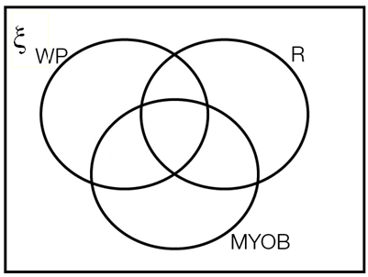

(b) Where on the Venn diagram are the employees involved in administration?

(c) If a person is selected at random, find the probability that the person is involved with:

(i) administration

(ii) at least two of the skills of word processing, MYOB and reception

(iii) no more than one of the skills of word processing, MYOB and reception

(iv) exactly one of the skills of word processing, MYOB and reception.

(d) If a person has MYOB skills, what is the probability they have word processing skills?

Question 24 7 marks [10.5]

A company has two machines that make armchairs.

* 95% of armchairs produced by Machine A are acceptable.
* 90% of armchairs produced by Machine B are acceptable.
* Machine A produces 40% of the armchairs manufactured at the factory.

(a) Complete the tree diagram to show this information. (In the diagram, G stands for acceptable and G' stands for not acceptable.)

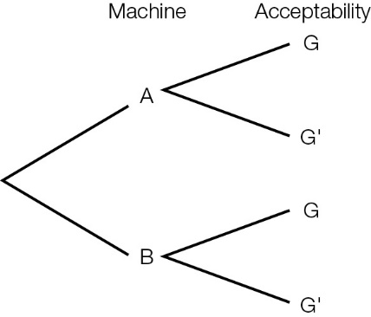

(b) (i) What is the probability that a randomly chosen armchair is an acceptable armchair manufactured by Machine A?

(ii) What is the probability that a randomly chosen armchair is an unacceptable armchair manufactured by Machine B?

(c) An armchair chosen at random is not acceptable. Find the probability that it was produced by Machine A. Give your answer as a fraction in simplest form.

Extended answer results: ___ / 15

TOTAL test results: ___ / 85